

This chart shows what the Year 5s thought would save the most energy.
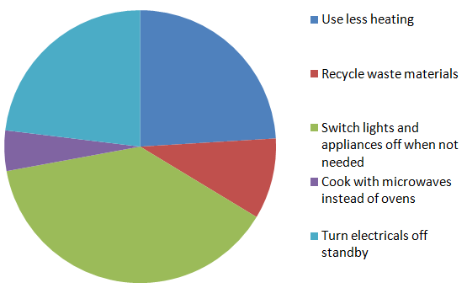
This shows the facts. Were they right?
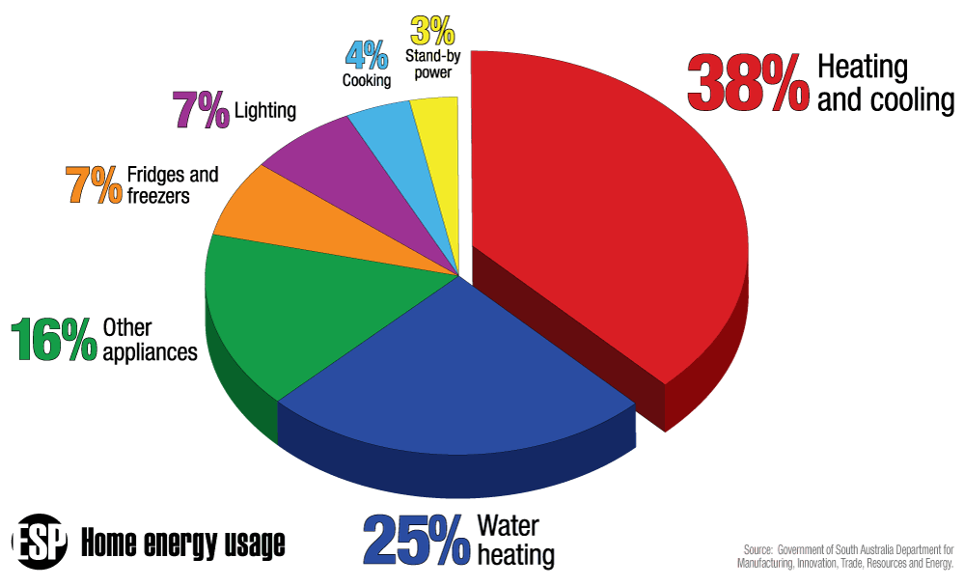

33% percent of Year 5 knew that you can save 10% of your energy bills through simple energy efficiency measures

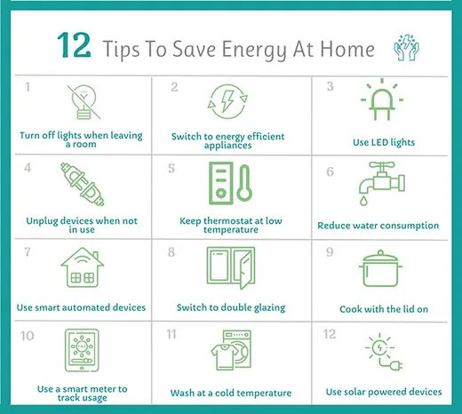

72 % of Year 5s think protecting the environment and reducing their impact on climate change is important

They are right. More than 25% of carbon emissions in the UK come from the energy we use every day in our homes! That’s why the little things you do at home will add up and help save our planet.

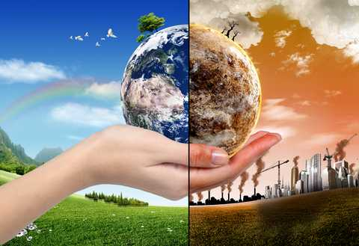

We rely on our environment to meet all our needs including providing us with food and water.

If we pollute our environment through extracting and burning fossil fuels, we are making it more difficult for us and all other animals to survive in.
Act local – Think global……

According to the World Wildlife Fund (WWF) humans are responsible for anything between 200- 200,000 species becoming extinct every year. Unlike the mass extinction events of geological history, the current extinction challenge is one for which a single species - ours - appears to be almost wholly responsible. This is often referred to as the 6th mass extinction.
We only have 1 planet, but at the moment, if everyone on earth
consumed as much as individuals do in the UK, then we'd need 3.5 Earths.

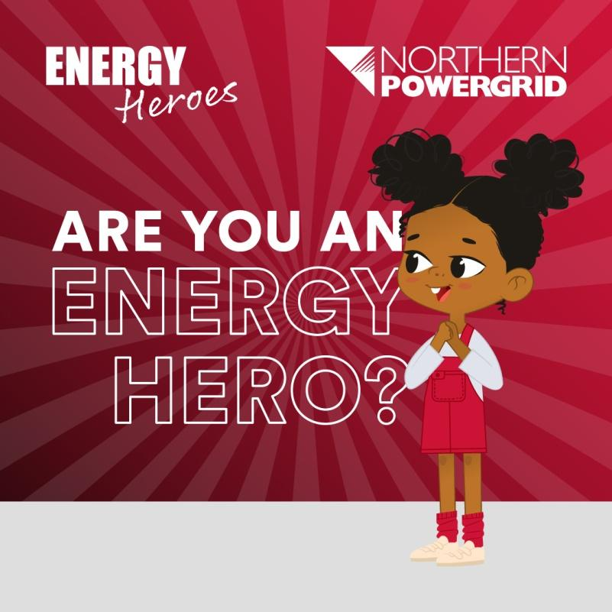

48% percent of Y5 pupils knew that too much carbon dioxide in the atmosphere causes climate change!

Pie chart showing how Year 5 pupils answered this question

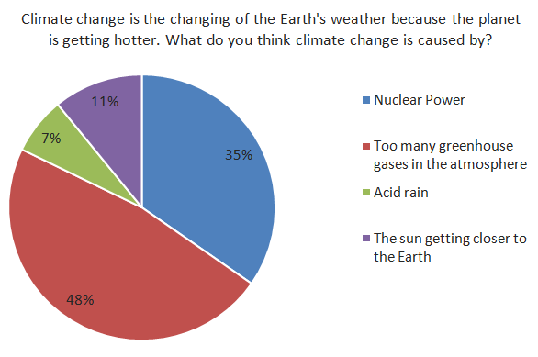
How does this cause climate change?

When burnt, fossil fuels release huge amounts of carbon dioxide (CO₂) into the Earth’s atmosphere. Over the last 200 years we have dramatically increased the level of CO₂in to the Earth’s atmosphere and according to 97% of the world’s scientists this is acting like a blanket around the earth, slowly increasing its temperature and causing our climate to change – this is dangerous to all life on our planet – including humans!

Is saving energy good for the planet?

Absolutely! 81.7% of the world’s energycomes
from the burning of fossil fuels!

See for yourself in these graphs from Energy Institute Statistical Review of World Energy 2023

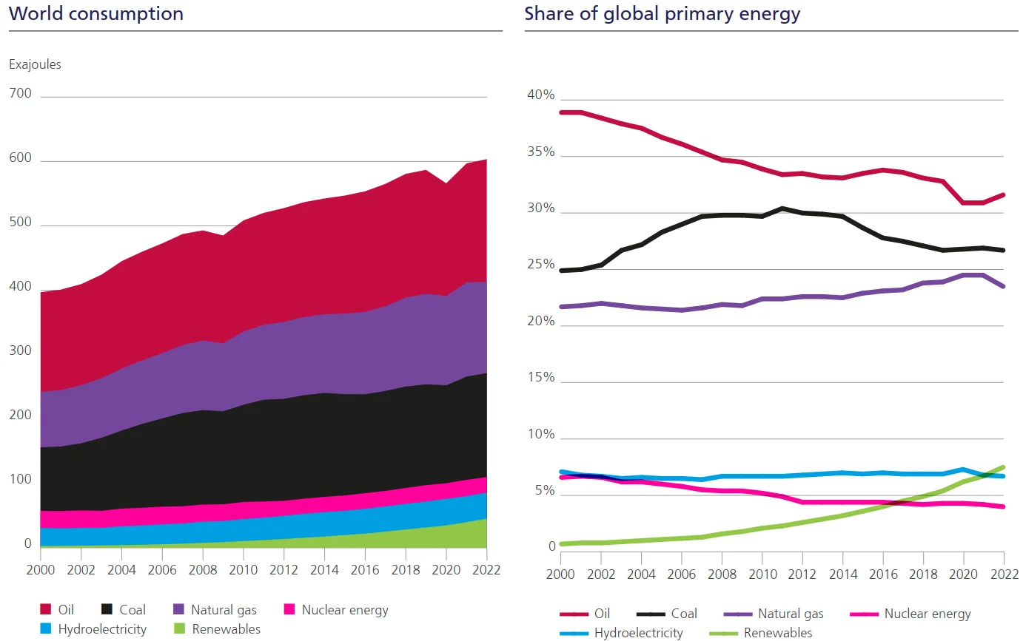

Your Year 5’s identified the following as the fossil fuels:
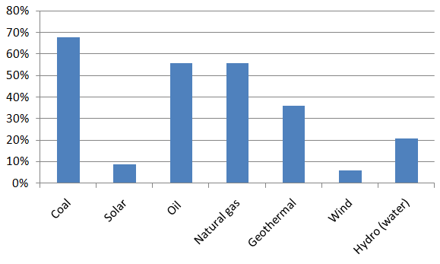

So, which are the fossil fuels?
Coal, oil, and natural gas are examples of fossil fuels.
Where do fossil fuels come from?
Fossil fuels are made from decomposing plants and animals. These fuels are found in Earth's crust and contain carbon and hydrogen, which can be burned for energy.
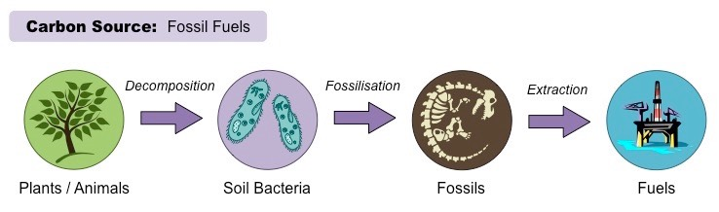

What alternatives do we have to
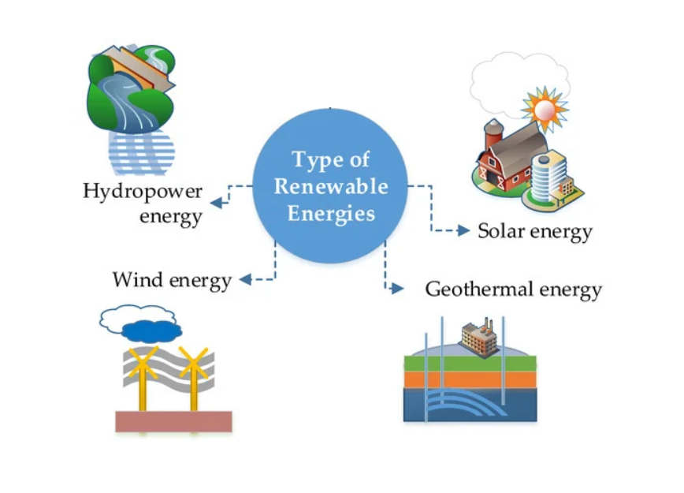
fossil fuels?


Super Solar Fact
The sun continuously hits the earth
with 35,000 times the amount of
energy required by all of us who
now use electricity on the planet! That’s 174,000,000,000,000,000 watt hours, or equivalent to 2,880 trillion light bulbs!

Your Energy Heroes School Audit
Ideas to Take Action!
Do you support these plans? How can you help to make them happen?

What can you do to increase energy efficiency in your school?
- Change all the windows to double glazing

- Speak to the Head teacher and site manager to ask about improvements to insulation

- Change all light bulbs to LEDs

How else can our school help to protect the environment?
- More tree planting

- Have meat free days

