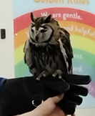
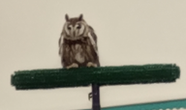
Milo

Species: Striped Owl
Age: 19 years old
Lifespan: In the wild these birds live to 8 or 9 years
In captivity live up to 30 years.
Habitat: Typically live in Peru, South America
Eyes: Dark Brown
Food: Likes to eat mice



