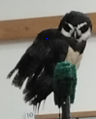
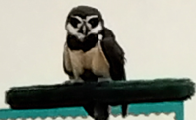
Domino

Species: Speckled Owl
Habitat: Amazon
Eyes: Yellow
Food: Likes to eat Monkeys
Fun fact: He uses whiskers to help him feel up close as his eyes won’t allow him to.


